2014 Past SAC 2 Questions

Question 2
Which one of the following statements about enzymes is not true?

A. Enzymes can only be denatured by an increase in temperature.
B. Enzymes may form temporary ion-dipole bonds with substrate molecules.
C. Enzymes speed up reactions by holding substrate molecules in positions necessary for reaction.
D. The tertiary structure of an enzyme may be altered if one amino acid in its primary structure is
substituted for another different amino acid.

Question 4
The α-amino acid alanine has the molecular formula C₃ H₇O₂ N. If three alanine molecules react together to form a tripeptide, the relative molecular mass of this tripeptide would be:

- 89
- 231
- 267
- 283

Question 7
Olive oil contains a high proportion of oils made from a fatty acid called oleic acid. The number of carbon to carbon double bonds in oleic acid is:

- 0
- 1
- 2
- 3

Question 8
The formula of the amino acid serine at pH 9.0 is:

- ⁺H₃NCH(CH₂OH)COO—
- ⁺H₃NCH(CH₂OH)COOH
- H₂NCH(CH₂OH)COO—
- H₂NCH(CH₂O—)COO—

Question 9
The following diagram shows part of a protein molecule. At which point would the protein chain be broken during digestion?
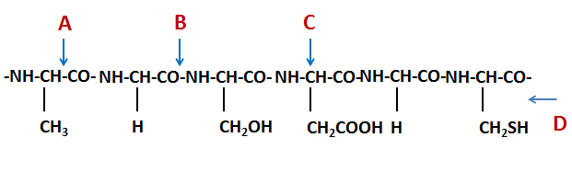
- At point A
- At point B
- At point C
- At point D

Question 11
The diagram below shows a section of a protein chain.
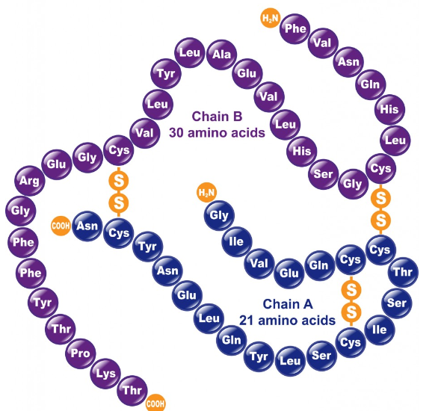
The bond between cysteine molecules (Cys) is used to maintain the

- Primary structure of a protein.
- Secondary structure of a protein.
- Tertiary structure of a protein.
- Primary, secondary and tertiary structures of a protein.

Question 12
Which of the following correctly describes the fundamental chemical structure of a strand of the DNA molecule?

A. Alternating phosphate groups and bases, with a sugar group attached to each base
B. Alternating sugar and phosphate groups, with a base attached to each phosphate group
C. A series of four bases, in sequences that determine what protein each segment codes for
D. Alternating sugar and phosphate groups, with a base attached to each sugar group

SECTION B – Short Answer Section

Question 4

a) The names, formulas, melting points and molecular masses for the fatty acids found in goat fat are shown in the table below.
Name | Formula | Melting point  (º C) | Molecular Mass
Caproic | C₅H₁₁COOH | -3 | 116
Caprylic | C₇H₁₅COOH | 16 | 144
Capric | C₉H₁₉COOH | 31 | 172

Explain why the melting point of a fatty acid increases as its molecular mass increases.

1 mark
b) The structure of a triglyceride found in goat is shown below.
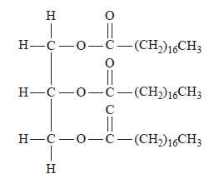
(i) Circle and name the functional group in the triglyceride molecule.
2 marks
(ii) Name the type of reaction when glycerol and the three fatty acids are reacted together to form the goat fat.

1 mark

C₇H₁₅
C₉H₁₉
C₅H₁₁

c) Timnodonic acid is a polyunsaturated fatty acid found in the brain. The number of carbon-carbon double bonds in a molecule of Timnodonic acid can be determined by titration with iodine, I₂, solution. An addition reaction takes place between the double bonds in Timnodonic acid and iodine.
25.00 mL of 0.100 M I₂ solution reacted exactly with 0.151 g of Timnodonic acid. The molar mass of Timnodonic acid is 302.45 g mol^{–1}.

- Calculate the number of C=C bonds in a molecule of Timnodonic acid.

3 marks
There are 20 carbon atoms in a molecule of Timnodonic acid.
- What is the formula of Timnodonic acid?

1 mark
Total = 8 marks

Question 5
a) The diagram below shows a small segment of another strand of DNA.
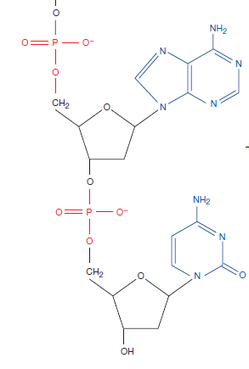
(i) Circle and name the purine base.
1 mark
(ii) Circle and label the phosphodiester linkage.
1 mark

(iii) Use arrows to show all of the possible sites for hydrogen bonding between one of the nitrogen bases and its complementary base
1 mark

b) A double stranded DNA segment has a total of 180 base pairs. There are sixty thymine bases present. Determine the number of cytosine bases in the segment.

1 mark
Total = 4 marks

